**VR Final Project Documentation**

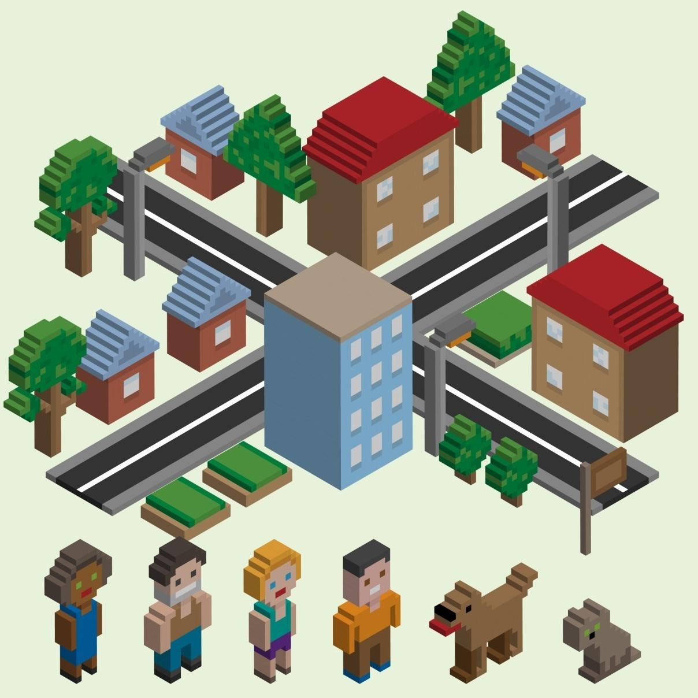

**JORDAN Township**

**Happiness All Around!!!**

**Table of Contents**

**Aim**

**Introduction**

**Overview**

**Required Specifications**

Hardware specifications

Software specifications

**Milestones**

Gathering 3D assets

Aligning the objects and adding UI elements

**Future Scope**

**Aim:**

**To create a Township Environment in VR.**

**Introduction:**

**The manager of JORDAN Township heartily welcomes you!!!**

**This township contains the necessary buildings and amenities which meets the basic requirements.**

**Overview:**

**First on opening you will get a UI panel, on pressing the yes, you will be directed into the township.**

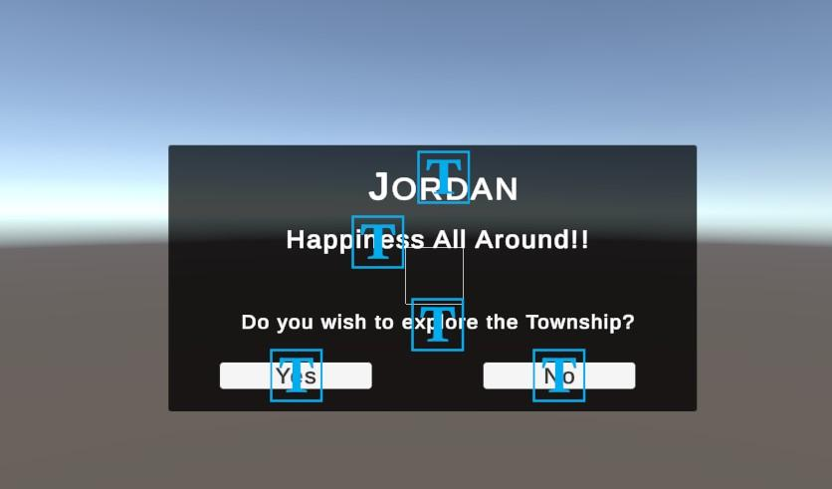

**By using the VR controller you can move around the town to explore. Our town has a lake in the middle surrounded by houses,apartments, church, brewery,gas station, play area, hospital, bank, police station, post office and some more elements. Here I’ll attch some snapshots.**

**Front view**

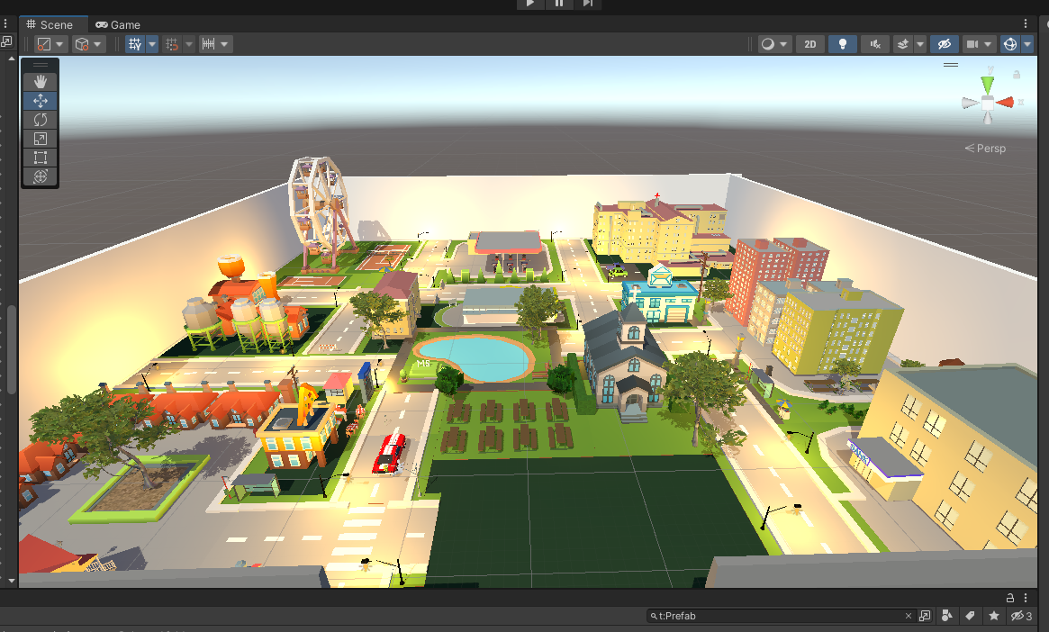

**Top view**

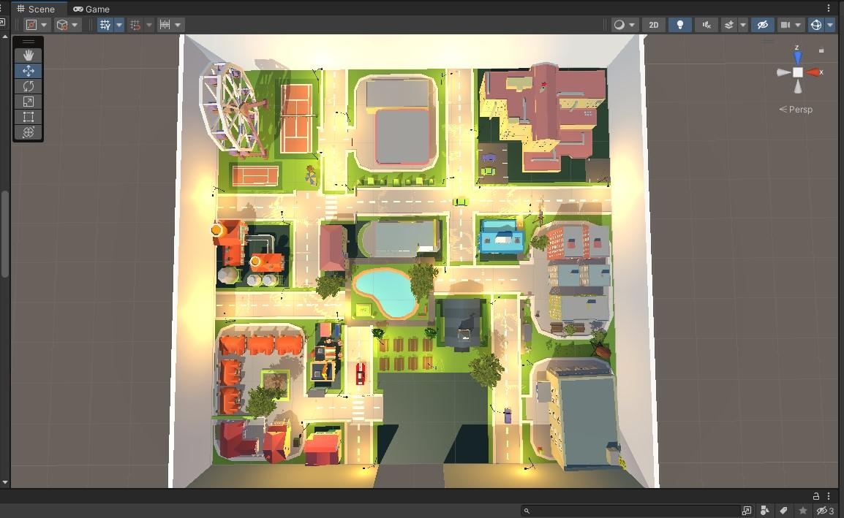

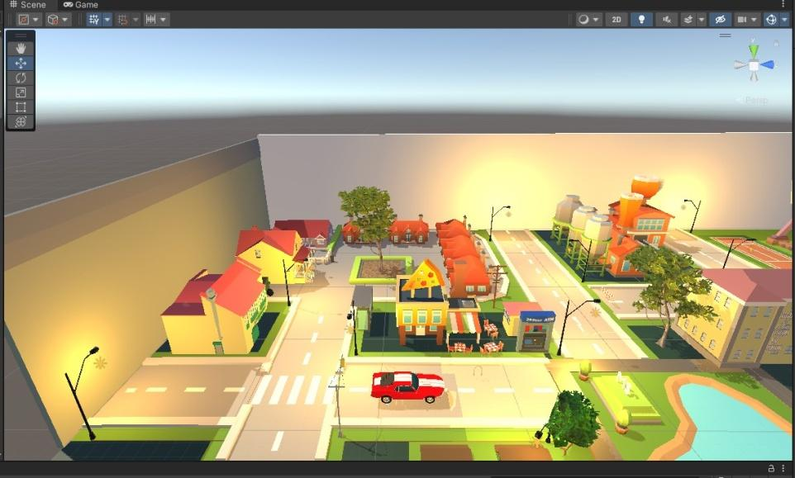

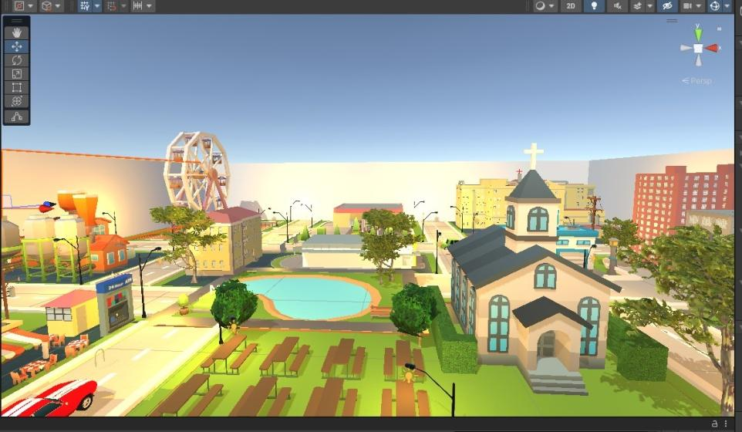

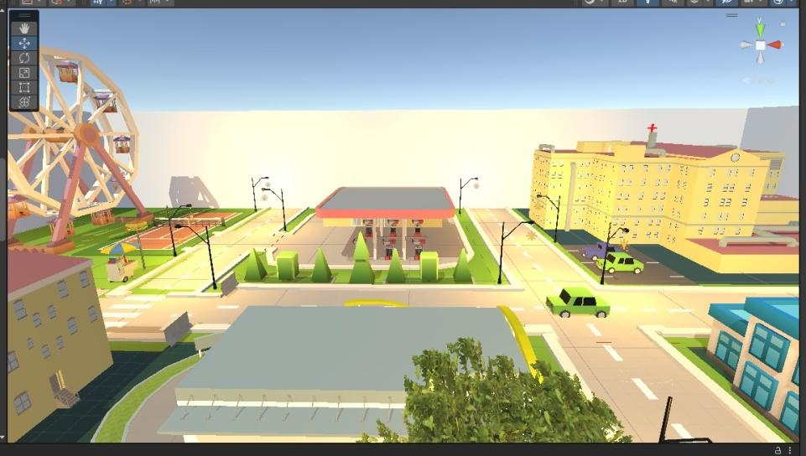

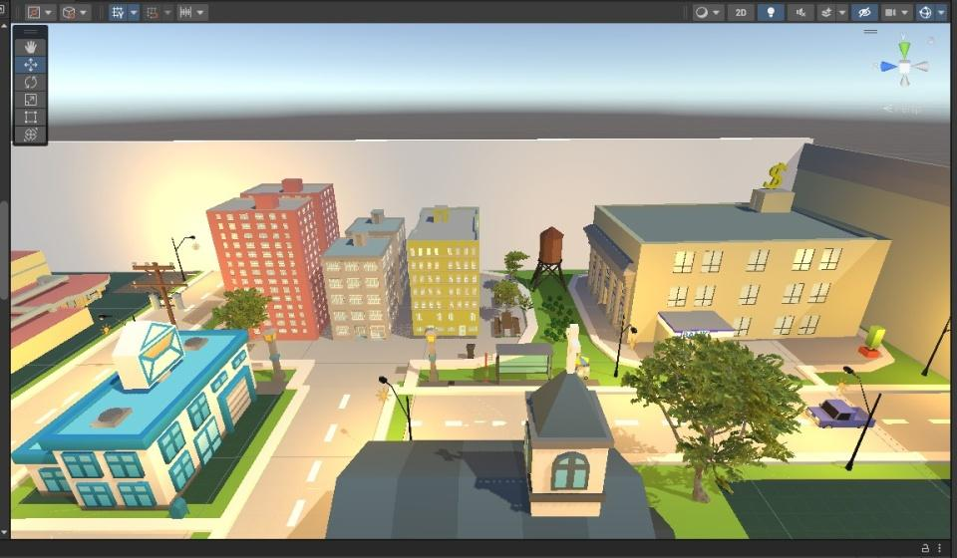

**Required specification:**

**Hardware Specifications:**

* Oculus Go VR Headset
* Oculus Go Controller

**Software Specifications:**

* Unity Game Engine
* Oculus SDK

**Milestones**

**Gathering 3D assets:**

* Polygon city pack
* Lowpoly road pack
* Prometo – car controller

**UI interface:**

Creating the necessary UI elements(buttons,panel,text box) for smooth switching between scenes.

**All the elements have been placed and aligned manually. It took nearly 12 hours just to get the elements to be placed in the right position.**

**Future Scope:**

**To add even more details and movement to all the vehicles.**